**Week 05-01:**

**Name:Snehan.S**

**Roll no:241801272**

**11.** Write a program that prints a simple chessboard. Input format: The first line contains the number of inputs T. The lines after that contain a different value for size of the chessboard Output format: Print a chessboard of dimensions size * size. Print W for white spaces and B for black spaces

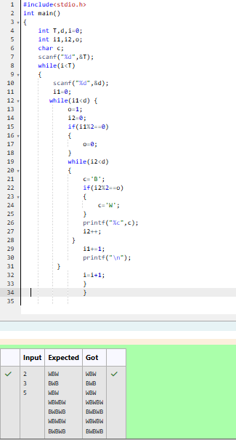

2. Write a program that prints a simple chessboard. Input format: The first line contains the number of inputs T. The lines after that contain a different value for size of the chessboard Output format: Print a chessboard of dimensions size * size. Print W for white spaces and B for black spaces

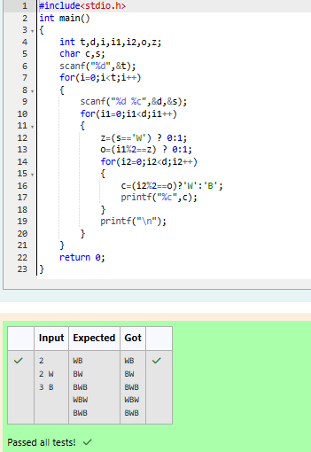

3. Decode the logic and print the Pattern that corresponds to given input. If N= 3 then pattern will be: 10203010011012 **4050809 ****607 If N= 4, then pattern will be: 1020304017018019020 **50607014015016 ****809012013 ******10011

